Monte Carlo Risk Engine

Model Overview
This Monte Carlo framework evaluates the distributional resilience of a leveraged facility under correlated macroeconomic stress.
The model simulates 10,000 scenarios over a 60-month horizon, incorporating:
- Correlated credit risk
- Refinancing failure at maturity
- Market freeze regimes
- Liquidity haircuts under stress
- Capital structure loss allocation
The output is a full distribution of total net income and tranche-level loss outcomes.
Simulation Architecture

2.1 Random Driver Structure
Each simulation path is driven by:
- One systematic macro factor: Z ~ N(0,1)
- Independent idiosyncratic shocks for:
  - default
  - LGD
  - margin
  - liquidity stress

2.2 Parameter Mapping

Default Rate
$$default_rate=base+shock_coef⋅(-z_{default}​)$$
Clipped to predefined bounds.

LGD
$$LGD=base+shock_coef⋅(-z_{lgd})$$
Also clipped to bounds.

Margin Shock
$$margin=base_coupon+shock_coef⋅(-z_{margin})$$

Refinance Failure Probability
At maturity:
$$pfail​=base+sensitivity⋅(-Z)$$
Higher macro stress → higher refinancing failure probability.

Liquidity Haircut
$$haircut=base+sensitivity⋅(-Z)$$
Haircut increases under stress.

Cashflow Mechanics

3.1 Asset Structure – Bullet Maturity
- Interest received monthly:
$$Interest_t​=Outstanding×coupon/12$$
- Principal repaid at maturity (Month H)
There is no amortisation prior to maturity.

3.2 Credit Loss
At maturity:
$$Credit Loss=Notional×default_rate×LGD$$
Defaults are assumed to crystallise at maturity.
Interest is fully accrued prior to default.

3.3 Liquidity Loss
If refinancing fails:
$$Liquidity Loss=Outstanding×haircut$$
This represents forced-sale liquidation under stress.
Liquidity loss is conditional on:
- maturity event
- refinancing failure

3.4 Funding Structure
The facility includes:
- Senior (A)
- Mezzanine (B)
- Junior (C)
- Warehouse (bridge funding)
Funding cost:
$$Funding Cost_t​=∑Balance_i​×Rate_i​$$
Balances are drawn according to structural priority.
Loss waterfall:
- Equity
- C tranche
- B tranche
- A tranche
- Warehouse

Regime Dynamics – Freeze Model

4.1 Regime Definition
The model incorporates a liquidity regime variable representing temporary market dislocation.
Let:
$$F_{t}∈\{0,1\}$$
where:
- $F_{t}=0$ denotes normal market conditions
- $F_{t}=1$ denotes a liquidity freeze regime
The freeze state represents impaired refinancing conditions and forced-sale dynamics.

4.2 Regime Activation
The initial probability of entering freeze is macro-dependent.
Let $Z$denote the systematic macro factor:
$$Z∼N(0,1)$$
The probability of entering freeze is defined as:
$$P(F_{1}=1)=Φ(a+bZ)$$
where:
- $Φ$is the standard normal cumulative distribution function
- $b<0$, so macro deterioration increases freeze probability
Thus, freeze activation is stress-contingent rather than independent noise.

4.3 Regime Persistence
Once activated, freeze follows a two-state Markov process:
$$P(F_{t}=1∣F_{t-1}=1)=p_{stay} \\ P(F_{t}=1∣F_{t-1}=0)=p_{enter}$$
with:
$$p_{stay}>p_{enter}$$
This introduces regime persistence.
Liquidity stress therefore has temporal continuity rather than being a single-period shock.

4.4 Impact on Refinancing
Under bullet maturity structure, refinancing occurs at maturity $T$.
Refinancing failure probability is defined as:
$$p_{fail}=base+α(-Z)+βF_{T}$$
where:
- $Z$captures macro stress
- $F_{T}$captures regime activation
- $β>0$represents freeze-induced tightening
Freeze increases refinancing failure probability additively.

4.5 Impact on Liquidation Haircut
If refinancing fails, liquidation occurs at a haircut:
$$haircut=base+γ(-Z)+δF_{T}$$
where:
- $δ>0$represents additional market illiquidity discount
Under freeze:
- Liquidation severity increases
- Recovery rates decline

4.6 Liquidity Loss Realisation
Conditional on refinancing failure:
$$Liquidity Loss=Exposure×haircut$$
Liquidity loss is therefore:
- Stress-dependent
- Regime-amplified
- Discrete (realised at maturity)
This creates non-linear jump risk under bullet maturity.

4.7 Transmission Through Capital Structure
Liquidity losses enter the loss waterfall:
- Equity absorbs first
- Junior tranche
- Mezzanine tranche
- Senior tranche
Given that freeze is regime-driven and clustered under macro stress, liquidity losses disproportionately affect equity in tail scenarios.

4.8 Structural Implications
The freeze regime introduces a second loss channel distinct from credit default:
- Credit Loss: borrower insolvency driven
- Liquidity Loss: market access driven
These channels are correlated through the macro factor but not identical.
This creates dual-channel tail amplification:
Macro stress
→ Freeze activation
→ Refinance failure ↑
→ Haircut ↑
→ Liquidity loss ↑
→ Equity convex downside

4.9 Model Characterisation
The freeze regime is:
- Exogenous (macro-driven)
- Persistent (Markov)
- Non-linear (affects refinancing probability and severity)
- Amplifying (interacts with leverage and bullet maturity)
It does not represent borrower insolvency, but rather market dysfunction.

4.10 Practical Interpretation
Empirically, the model shows:
- Liquidity loss probability ≈ 11% overall
- ≈ 59% in worst 5% scenarios
This confirms that freeze acts as a regime-dependent tail amplifier rather than a baseline risk driver.

Output Metrics
For each simulation path, the model computes:
- Total Net Income
- Equity Return
- Credit Loss
- Liquidity Loss
- Tranche-Level Losses
- Emergency Funding Usage
Distributional statistics reported:
- Mean NI
- 5th percentile NI
- Probability of loss
- Corr(NI, credit_loss)
- Corr(NI, liquidity_loss)
- Tail decomposition (worst 5%)

Key Results

6.1 Simulation Configuration
The results presented in this section are generated under the following configuration:
- Horizon: 60 months
- Number of Monte Carlo paths: 10,000
- Random seed: 42 (results fully reproducible)
- Bullet maturity structure
- Correlated macro factor driving credit and liquidity parameters
- Regime-dependent refinancing failure and haircut severity
All statistics below are computed across the full distribution of simulated outcomes.

6.2 Distribution of Net Income

Expected Performance
- Expected Total Net Income ≈ $30.3m
- 5th Percentile Net Income ≈ –$28.7m
- Probability of Equity Loss ≈ 15.7%
The mean outcome reflects strong base-case structural performance.
However, the left tail exhibits significant downside dispersion.
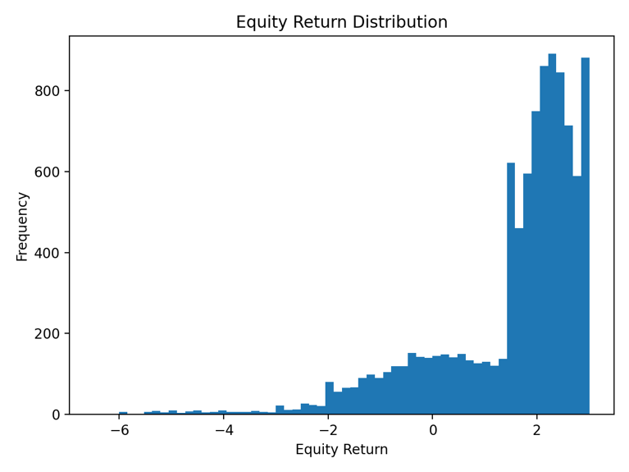
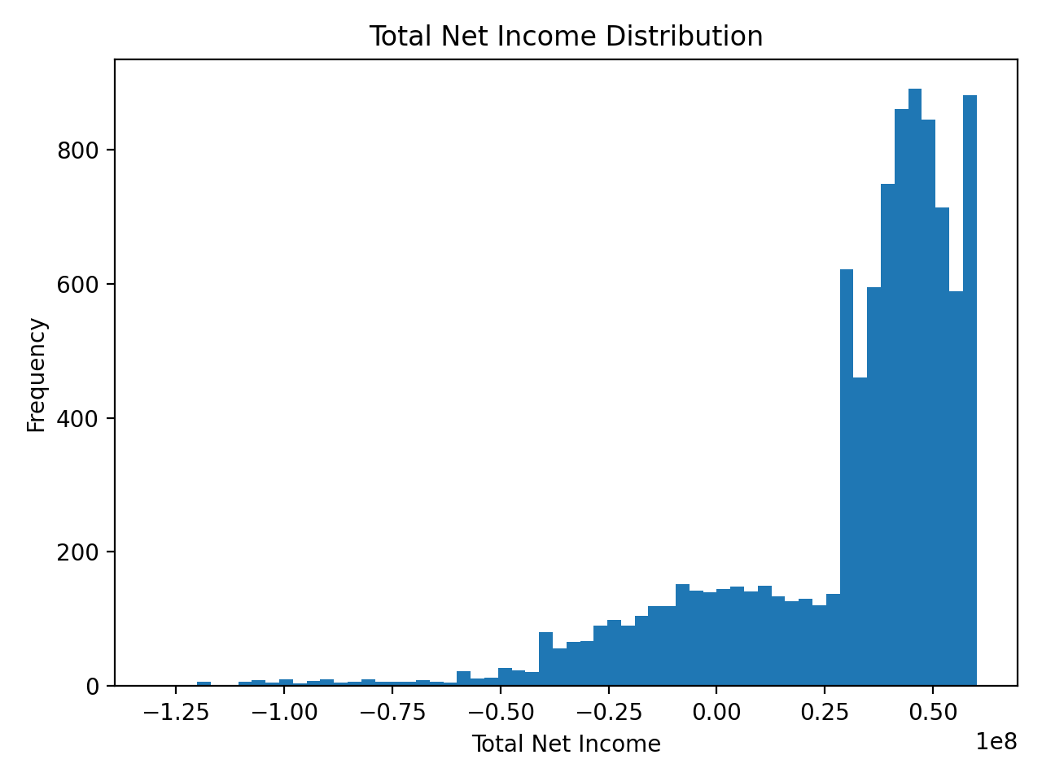
Equity returns display left-skewed volatility consistent with leveraged exposure to correlated stress.

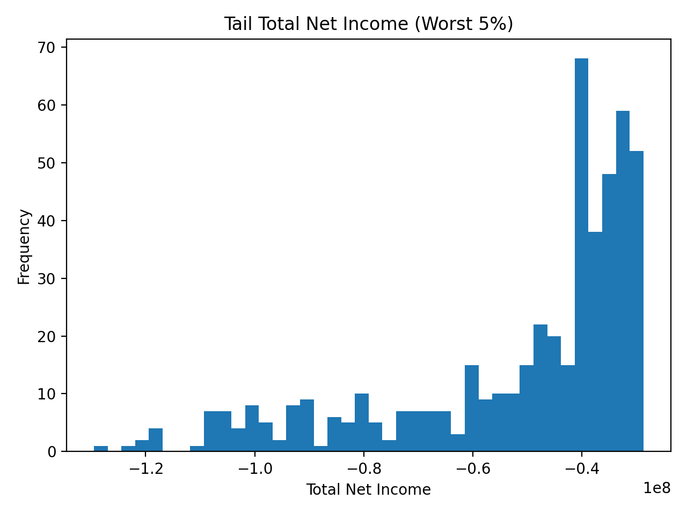
6.3 Credit Loss Channel
Credit loss is driven by correlated default rate and LGD shocks.
Summary diagnostics:
- Corr(NI, credit_loss) ≈ –0.79
- Mean credit loss (all scenarios): material but diversified
- Mean credit loss (worst 5%): significantly elevated (~$50m+)
Credit remains the primary explanatory variable for net income deterioration.
Clustering under macro stress materially increases tail severity.

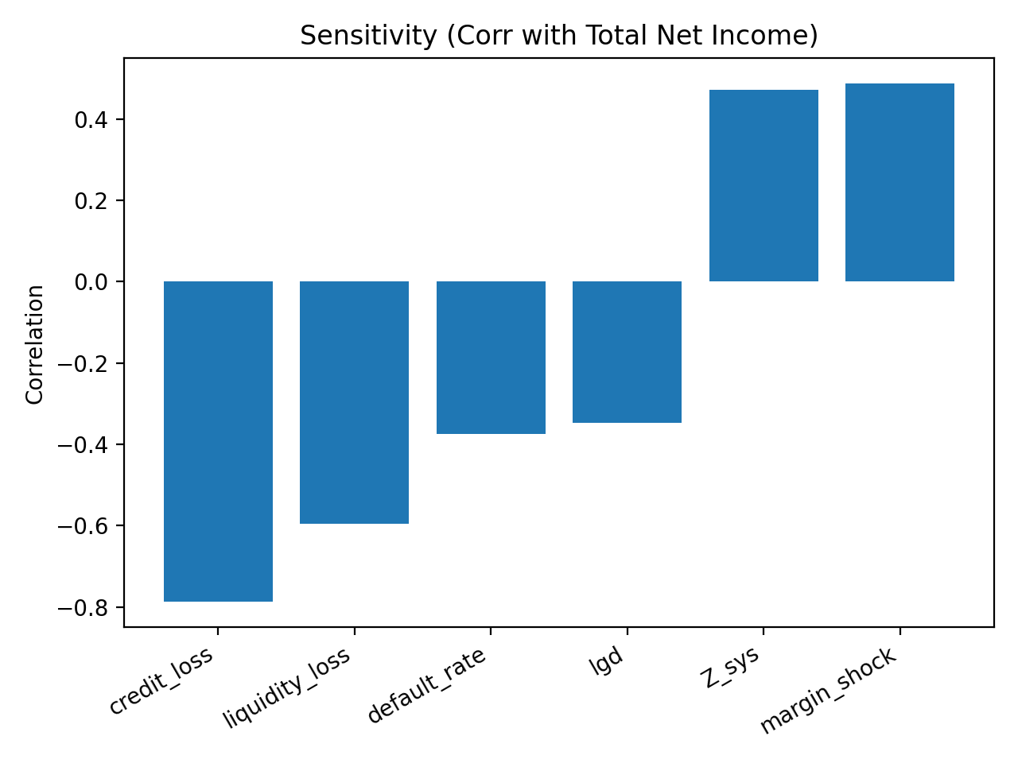
6.4 Liquidity Loss Channel
Liquidity loss emerges through refinancing failure at maturity.
Key diagnostics:
- Corr(NI, liquidity_loss) ≈ –0.60
- P(liquidity_loss > 0) ≈ 10.9%
- P(liquidity_loss > 0 | worst 5%) ≈ ~59%
This confirms liquidity shocks are regime-dependent rather than baseline drivers.
In moderate scenarios, liquidity effects are limited.
In tail regimes, liquidity materially amplifies downside exposure.
Liquidity therefore functions as a secondary but structurally relevant loss channel.

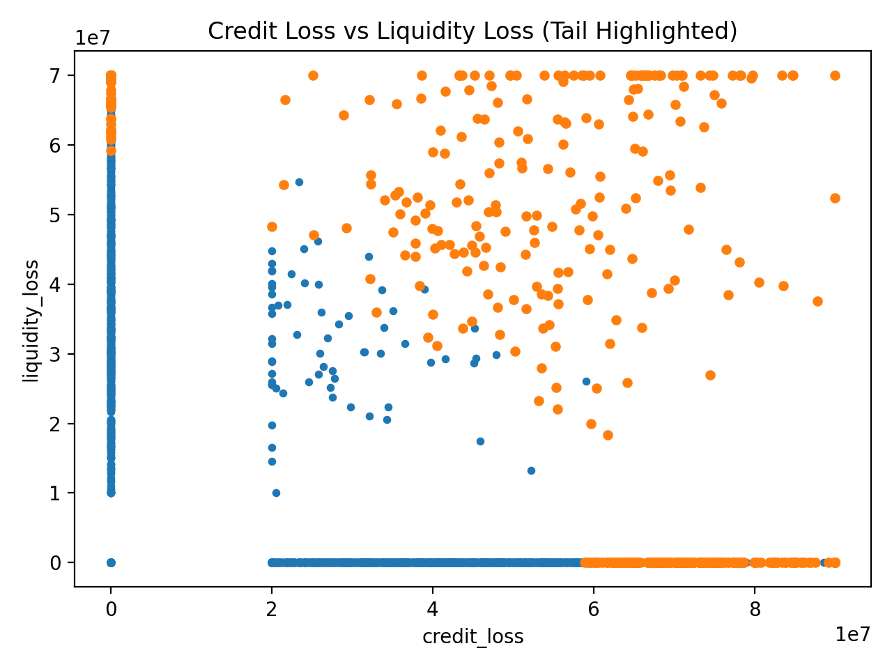
6.5 Tail Decomposition
To quantify dual-channel interaction, we examine the worst 5% of outcomes.
Tail diagnostics show:
- Mean credit loss significantly elevated
- Mean liquidity loss materially increased
- Liquidity activation frequency increases from ~11% (overall) to ~59% (tail)
This confirms that:
Credit remains primary in magnitude,
Liquidity emerges disproportionately in severe stress.
Tail risk is therefore not single-factor driven.
Tail Decomposition
scope | n | ni_mean | ni_p5 | ni_min | credit_mean | credit_p95 | credit_max | p_credit_gt_0 | liq_mean | liq_p95 | liq_max | p_liq_gt_0
ALL | 10000 | 30348130.794863100 | -28652168.283698200 | -129484587.35028400 | 9934663.706594870 | 58215767.87146030 | 90000000.0 | 0.2241 | 4650664.590089610 | 43005375.784930800 | 70000000.0 | 0.1086
TAIL_WORST_5PCT | 500 | -51325486.22785860 | -102834541.80702500 | -129484587.35028400 | 52812970.86207060 | 87101178.3846654 | 90000000.0 | 0.822 | 34258072.05943130 | 70000000.0 | 70000000.0 | 0.588

6.6 Interpretation of Results
These results confirm:
- Structural resilience at debt level under base-case stress
- Equity-level convex downside under leverage
- Credit as primary loss channel
- Liquidity as tail amplifier
- Correlation as key driver of clustering
The interaction between bullet maturity and correlated macro stress introduces non-linear tail amplification effects not observable in deterministic cashflow projections.

Model Assumptions
Key assumptions include:
- Defaults realised at maturity
- Single systematic macro factor
- Linear shock mapping with clipping
- Static tranche limits
- Deterministic interest accrual
- No dynamic borrower behaviour

Model Limitations

1. Single Factor Dependence
The model uses one systematic factor. Real markets may involve multiple correlated macro drivers.

2. Static Parameter Mapping
Shock sensitivities are linear. Non-linear behavioural responses are not explicitly modeled.

3. Simplified Refinancing Process
Refinancing failure is probability-based, not supply-demand equilibrium based.

4. No Secondary Market Dynamics
Forced-sale haircut is exogenous rather than derived from price impact models.

5. No Dynamic Portfolio Evolution
Portfolio size and composition are static over horizon.

Positioning
This model is designed for:
- Structural risk diagnostics
- Distributional stress testing
- Capital structure analysis
- Tail risk decomposition
It complements deterministic facility models by introducing stochastic clustering and liquidity regime interaction.

